Radix MDM Support Center Guide

  - Radix Device Management Platform

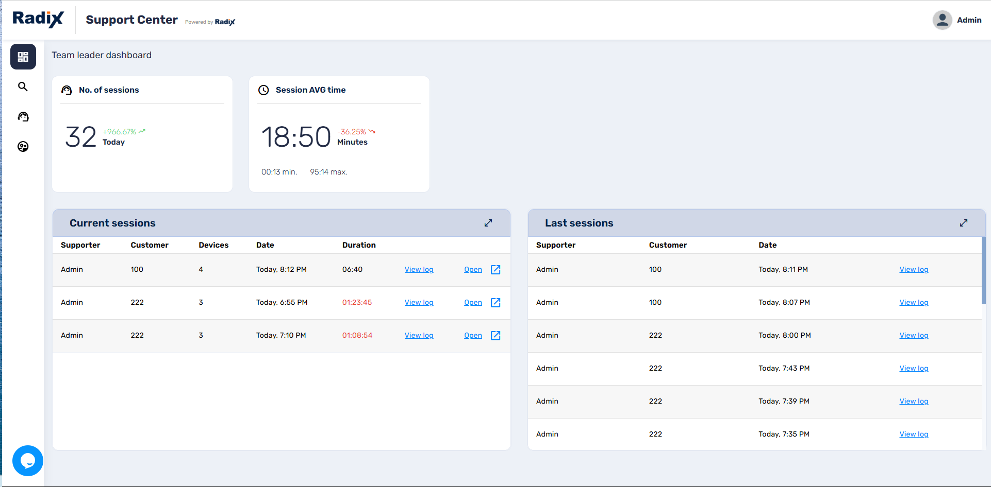

Table of Contents
Table of Contents 2
1 Introduction 3
2 Support Center Dashboard 4
2.1.1 No. of Sessions 4
2.1.2 Session AVG time 5
2.1.3 Current sessions: 5
2.1.4 Last Session: 6
3 Customer Search Screen 8
4 Household View Console 10
5 Selected Devices Screen 11
6 Example of Support Center Features 14
7 Further Resources 19

Introduction

The Radix Device Management Support Center allows you to keep track of support sessions for Radix Device Manager customers and their fleet of devices. By creating a history of device servicing sessions, it can display trends in the number of customer complaints, as well as the average amount of time spent on servicing remote devices.
The Support Center interface will allow you to:
- View statistics regarding the device usage sessions on the devices, and the duration of the service calls,
- Request an active session to service a remote device,
- Search and display the servicing history for customers or specific devices,
- View the entire “household” of a customer’s fleet of devices and their servicing history, and
- Connect to a specific device and analyze the status and performance of its hardware, as well as the apps being used on the devices and any corrective actions that have been made.

Support Center Dashboard
The Support Center Dashboard is the first screen that you see when clicking on the Support Center icon in the Radix Device Manager.
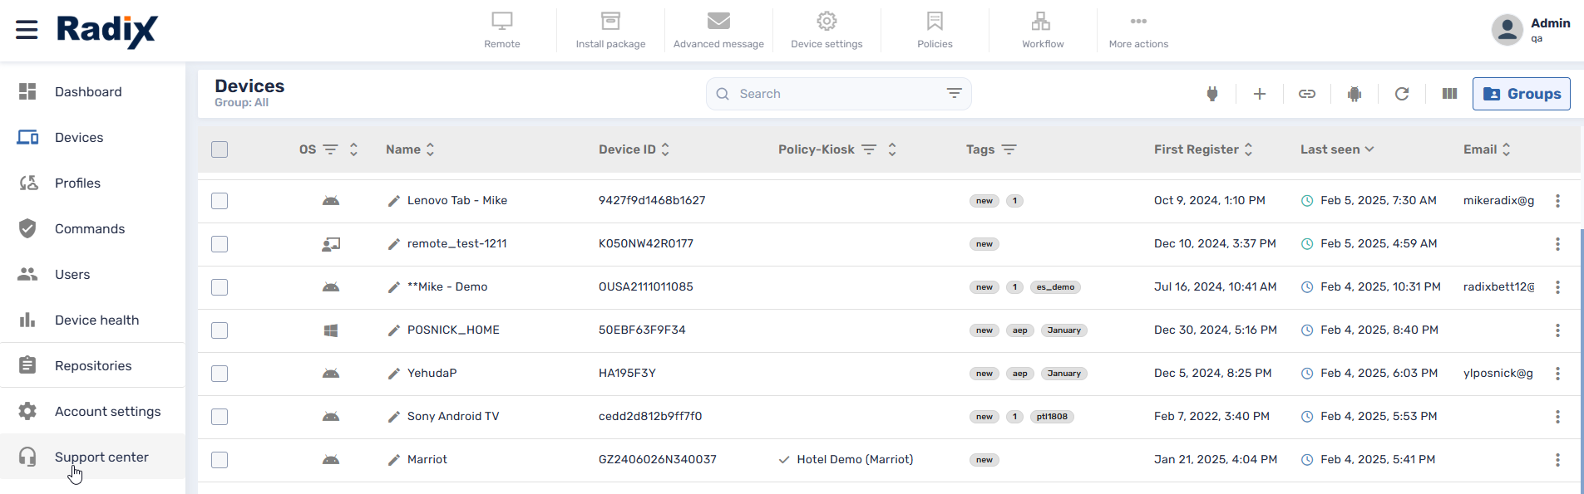
Figure ‎2-1: Location of Support Center icon in Device Manager screen
At first, the Support Center Dashboard screen will show no device servicing sessions. Over time, it will start to display the number of usage sessions, and the average amount of time for each usage session. The data is updated constantly. If you refresh the page on your browser, the session tracking will start over again.
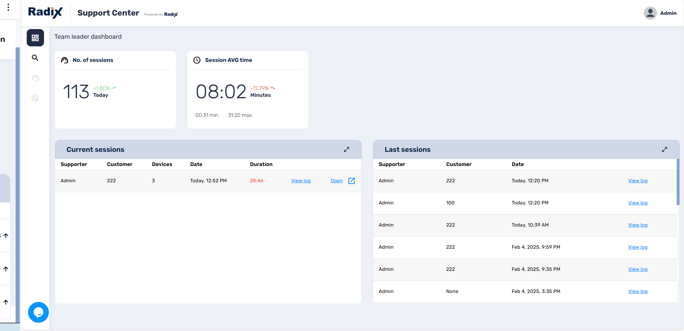
Figure ‎2-2: Support Center Team Leader Dashboard
The fields are as follows:

No. of Sessions
The number of service sessions held today. It will also show any trends, if there are more or less support sessions compared to yesterday.
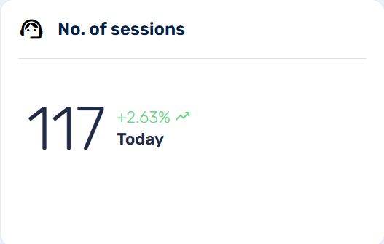

Session AVG time
The average duration of each device session. It will also show any trends, if the average duration of support sessions was less or more than yesterday.
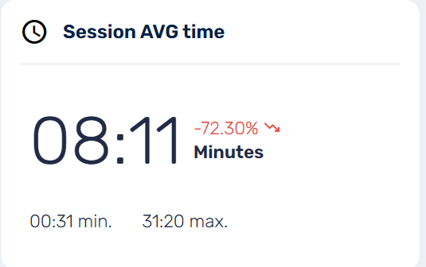

Current sessions:
This will show the current support sessions for each client, the number of devices in their fleet, and the duration of the current service sessions. When you initiate an action on a device in the Household View or Selected Devices screen, the session will then appear in the list of Current Sessions.
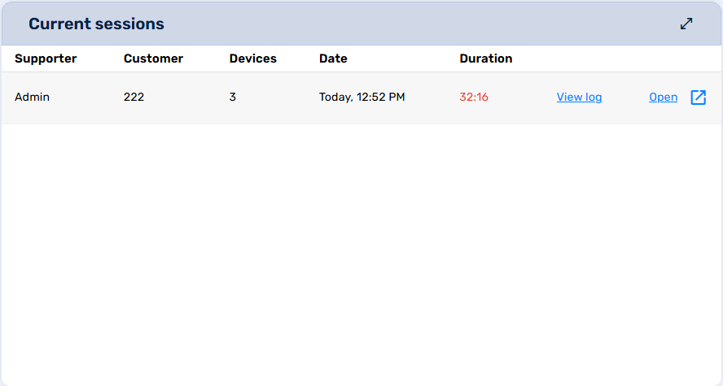
You have two clickable options in the Current sessions window:
- View log: Clicking on View log presents you with a history of the service sessions for that customer:
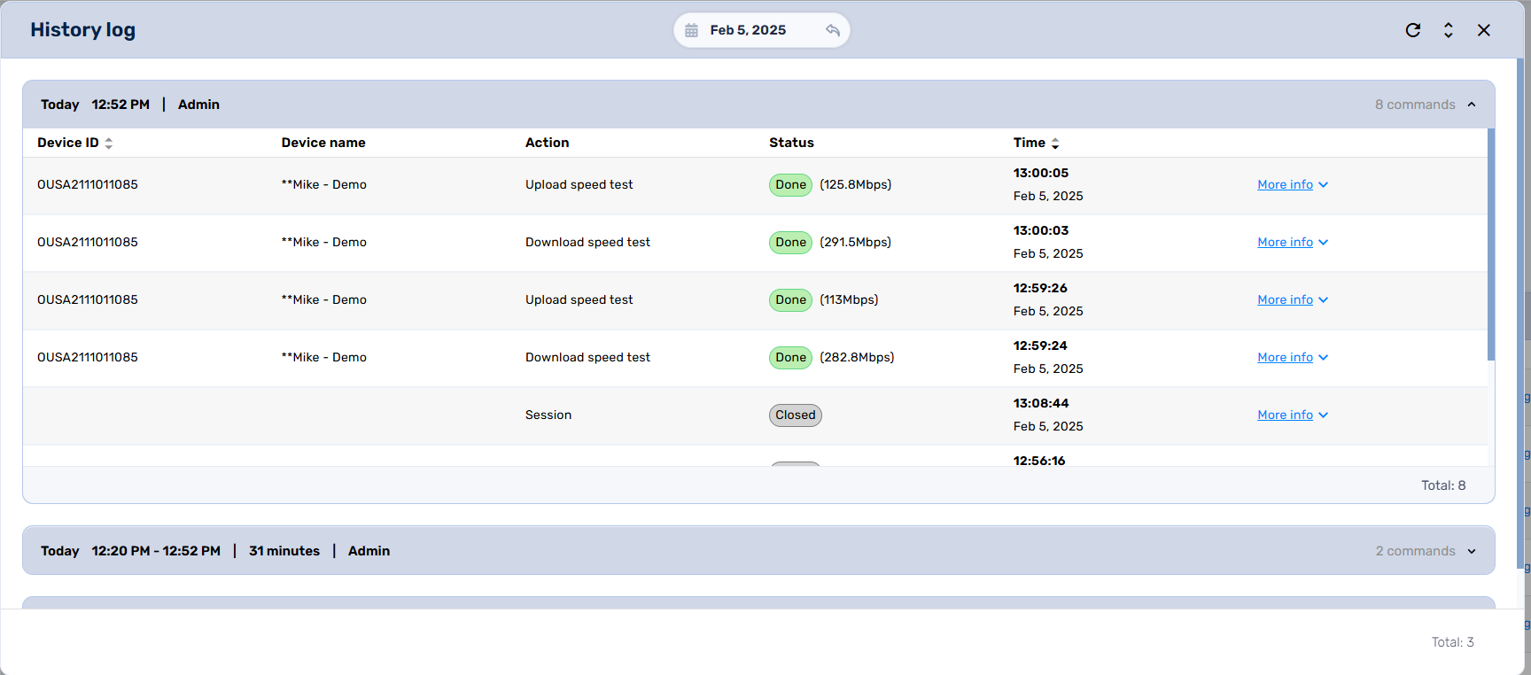
Figure ‎2-3: History of servicing activities performed on a customer's devices
- Open: Clicking on Open will open up the Household View console for this customer:
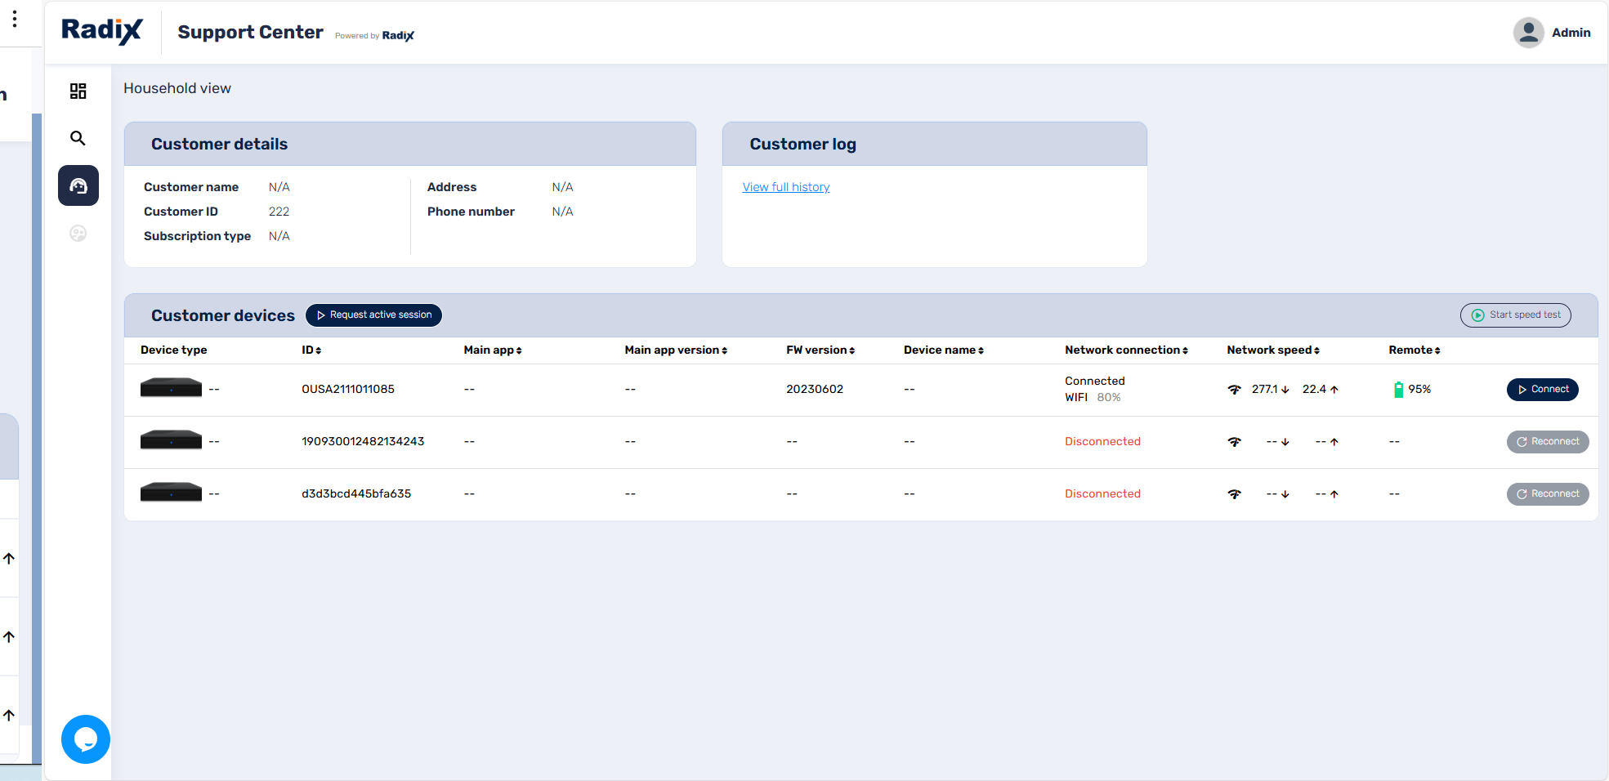
Figure ‎2-4: Household View console shows the customer details and their devices

Last Session:
This window will display the service sessions in chronological order. Each customer being serviced will be assigned a customer ID number.
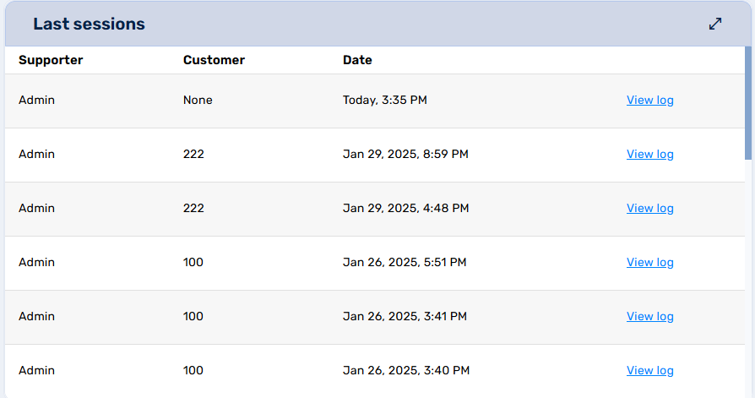

If you click on View log for a specific customer, the following window opens:
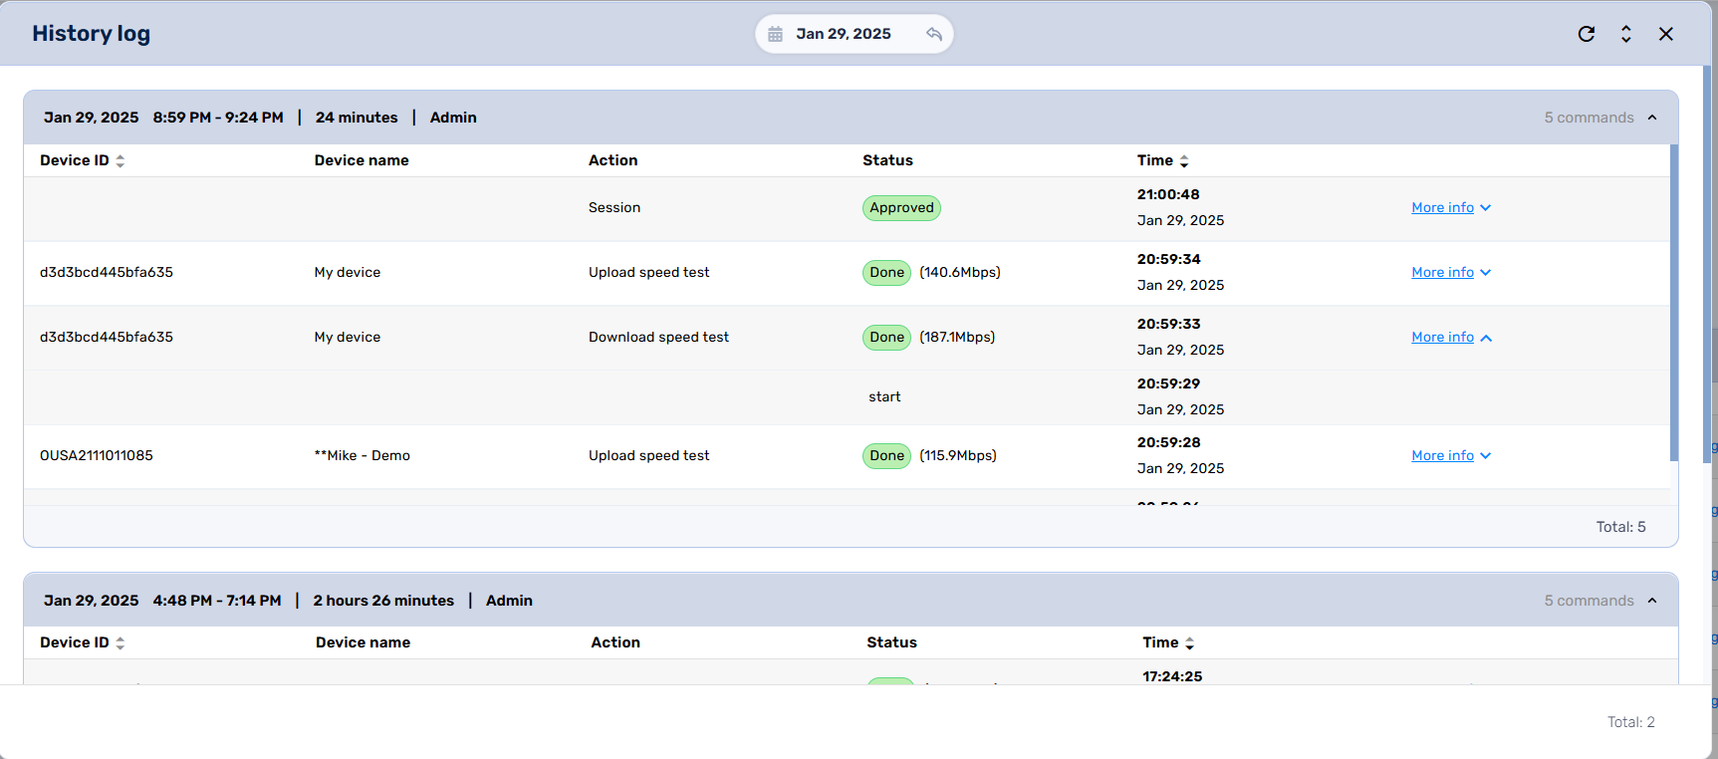
It displays:
- The גate and time of the service call
- The duration of the service call
- Who provided the servicing
Clicking on More info in the History log will display:
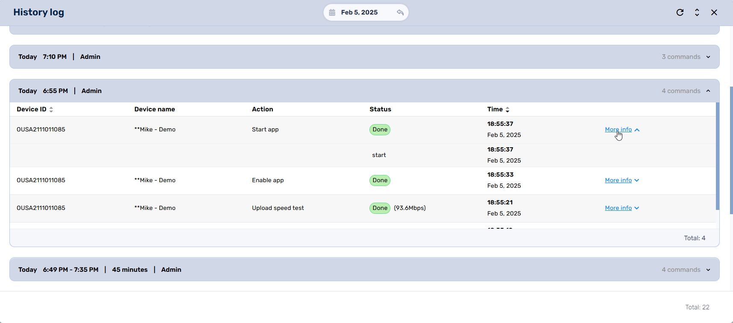
- The device’s ID and the device name
- The action performed
- The status of the action
- The time and date of the action.

Customer Search Screen
When we click on the Customer Search icon in the sidebar menu, this opens the Customer Search console. It allows you to search for customer support history either by Customer ID (to view support offered to the customer’s fleet) or Device ID (to view support offered to a particular device).
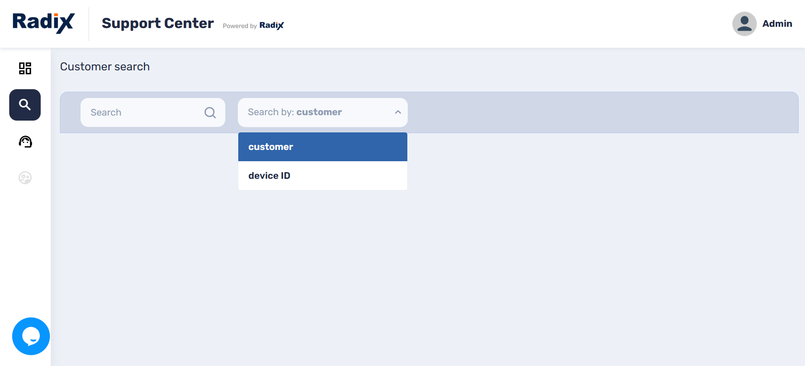
For example, we will enter the customer ID “222” in the Search Bar. This displays the following information.
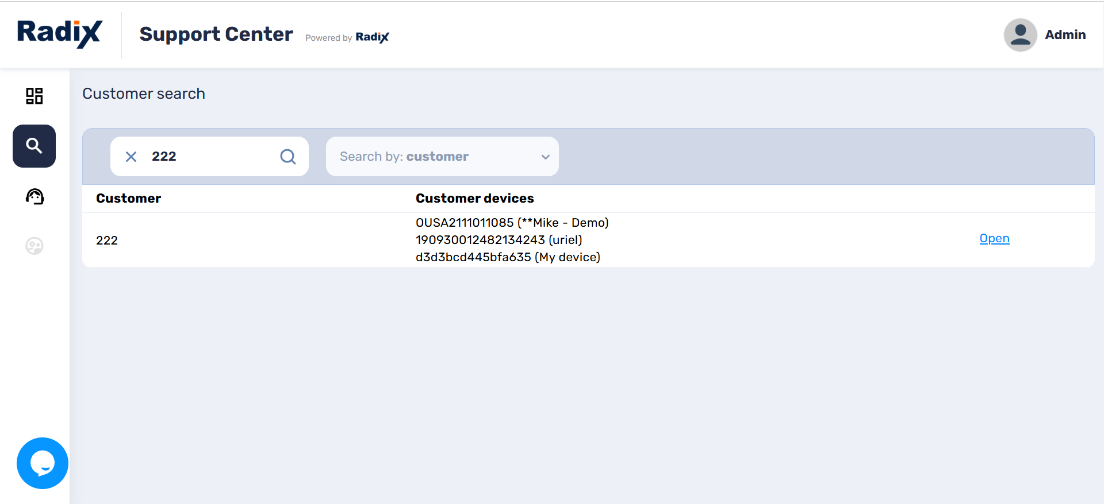
Figure ‎3-1: Search by Customer ID
It shows that Customer 222 owns three devices.
If we choose to search by Device ID, the display appears as follows:
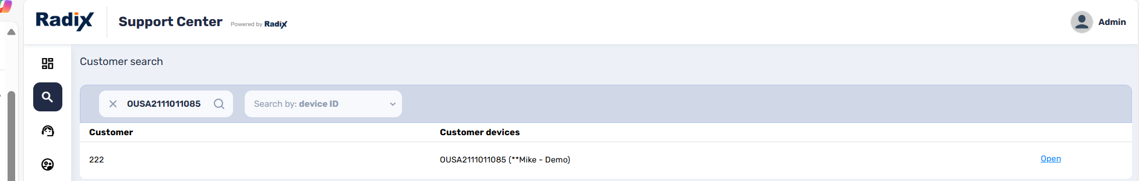
Figure ‎3-2: Search by Device ID
Clicking on Open on the right displays the Household View Console, which we examine in the next chapter.

Household View Console
When you open a customer log from the Customer Search window, the following screen opens:
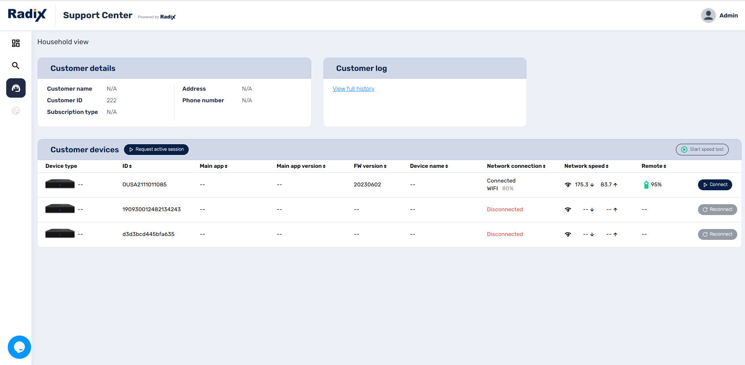
Figure ‎4-1: Household View Console
We see that only one of Customer 222’s three devices are presently connected to a Wi-Fi network: the device with Device ID OUSA2111011085.
If we click on Request active session, we will receive a notification in the lower right corner that a session request has been sent.
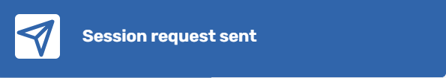
The customer will receive a notification on their remote device, and the system will wait for the customer’s approval to initiate a service session.
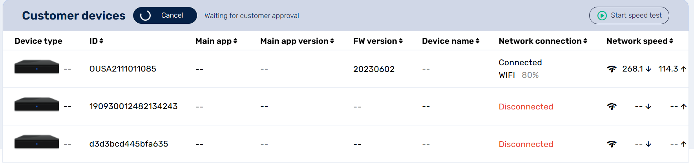
Upon clicking on Start speed test on the right, the upload and download speeds for the active devices will be checked.
If we click Connect, the Selected Devices console opens, which we will examine in the next chapter.
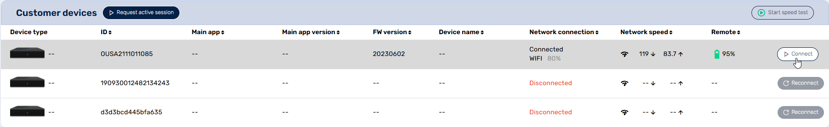
Figure ‎4-2: Location of Connect button in the Household View console

Selected Devices Screen
The Selected Devices console will display the following information about the device:
- Device health: Information about the device’s Bluetooth and network connectivity, CPU temperature, the number of reboots performed in the last 24 hours, available memory on the device, and more. The screen also displays any outstanding performance issues.
- Device info: Information regarding the device’s physical location, ID No., and history of previous service sessions.
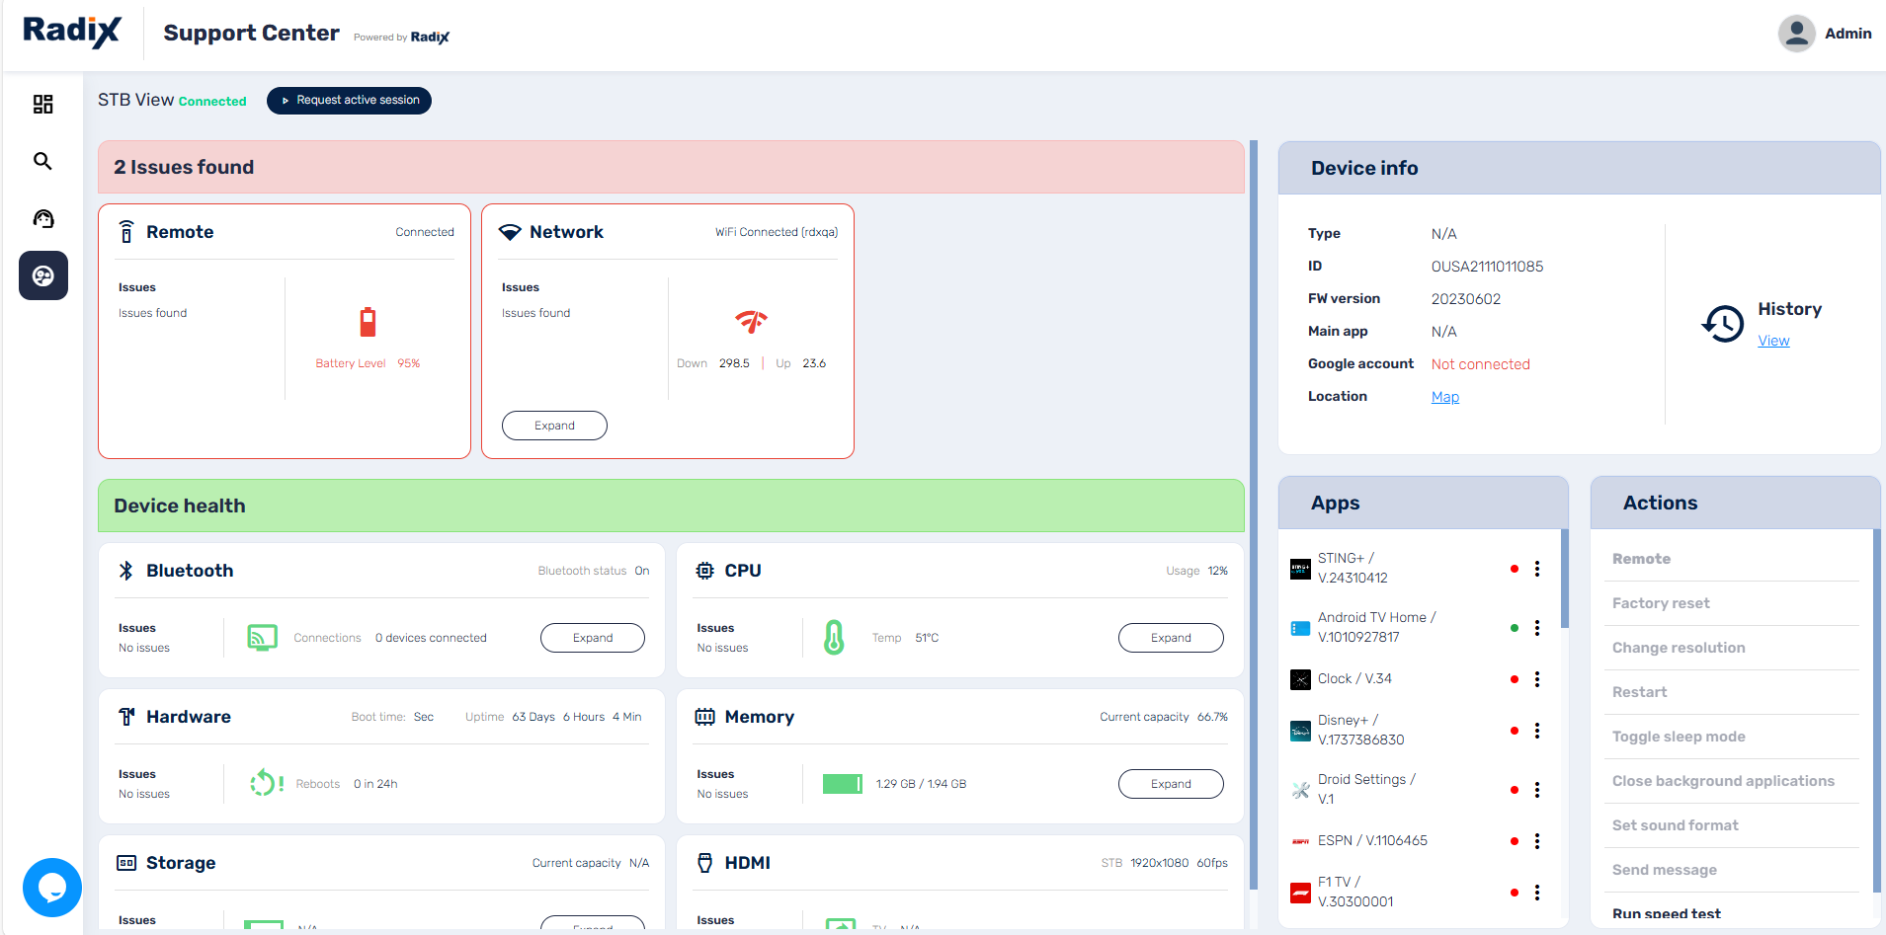
If we click on View in the Device info pane, the History Log of the device opens:
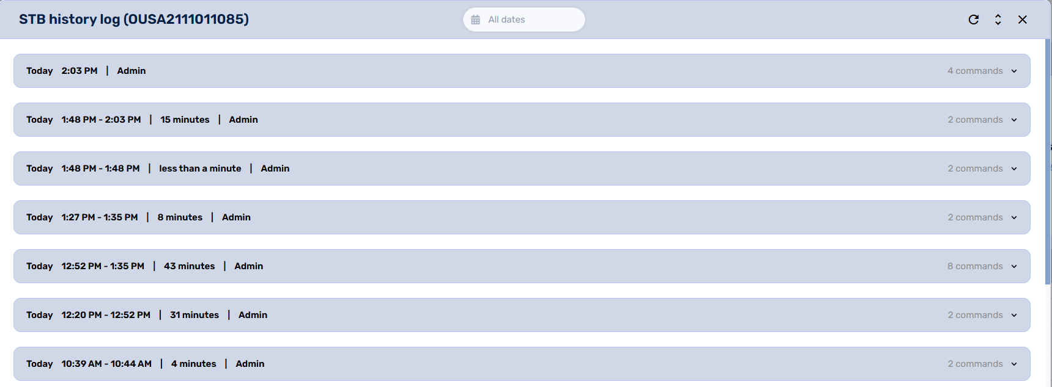
Figure ‎5-1: Device servicing history log
- Apps: This displays the apps installed on the device. A green dot indicates an app that is currently running, while a red dot indicates an app that is presently inoperative. Clicking on the three-dot menu next to an app will open the following grid of commands:
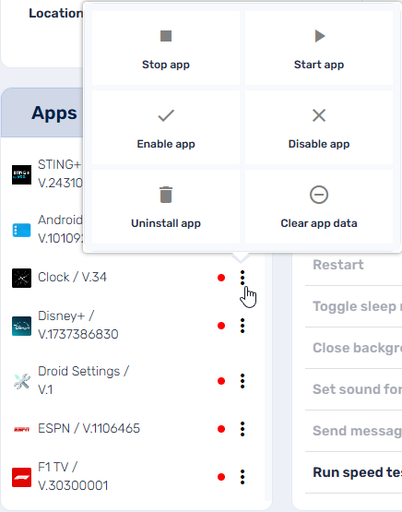
The person servicing the device can start, stop, enable/disable an app, or clear the app data, if the customer has any issues with the functioning of the app.
- Actions: The servicing actions that have been performed on the device. The tests that are currently being performed on the device will be displayed in bold print. In the example below, we see that “Run Speed Test” is being performed presently.
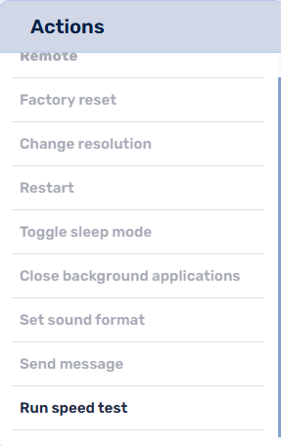

Example of Support Center Features
To illustrate the way in which the Radix Support Center tracks devices, we will start a session that tracks upload and download speed and runs apps on a device.
- Open the Support Center Dashboard. Initially, we see the following display:
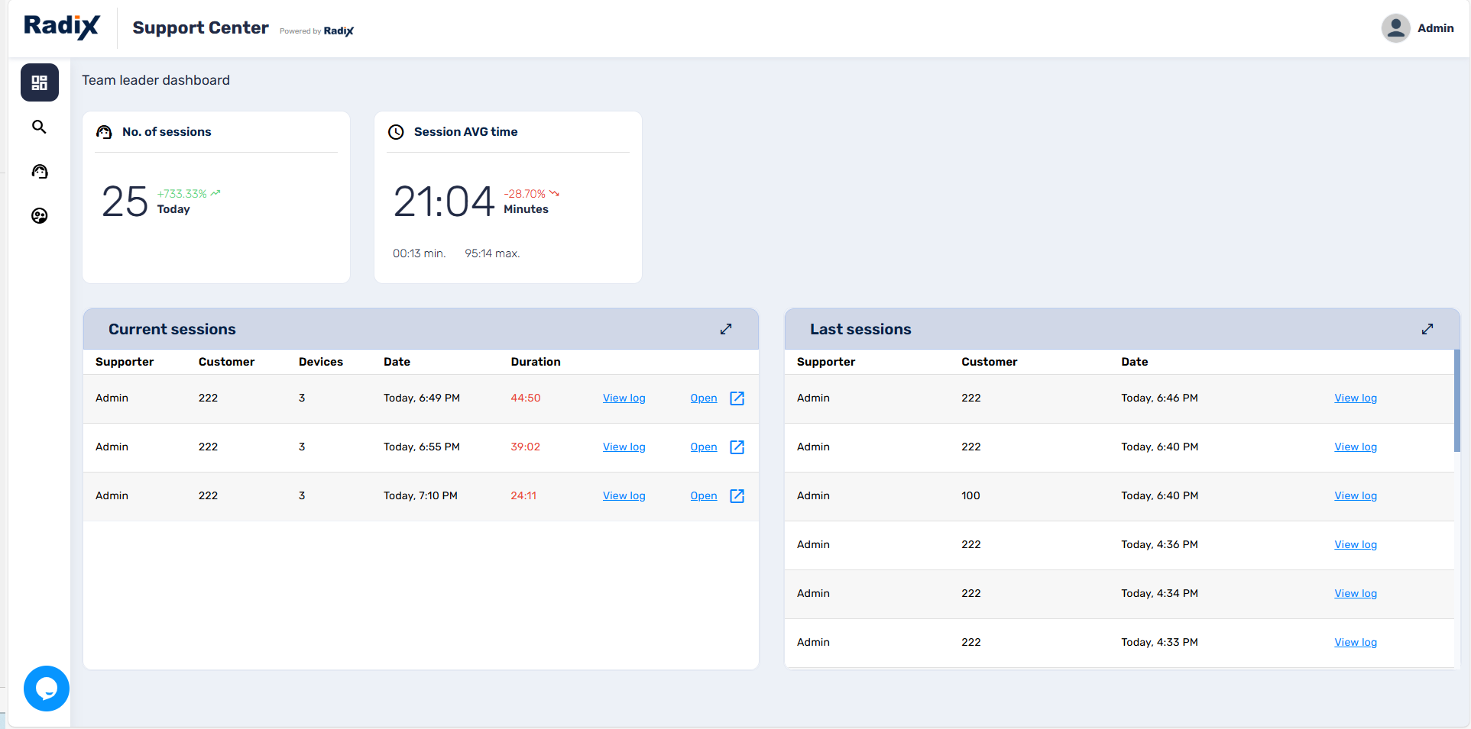
- We will click on the Customer Search icon in the sidebar menu, to open the Customer Seach Screen. We enter Customer ID “222”, to view the devices enrolled under this customer:
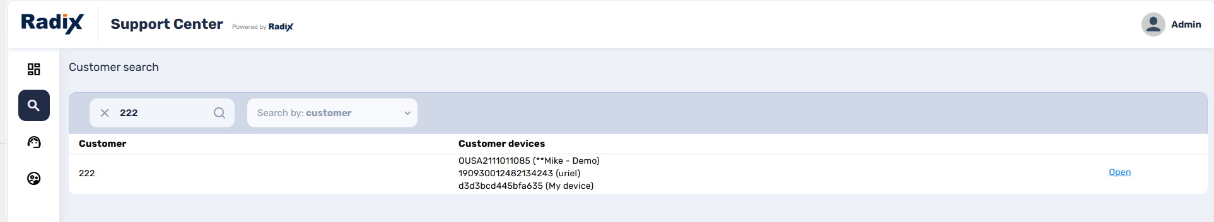
- Click on the row of the customer or click “Open”. (You can also click on the “open in a New Tab” icon.)
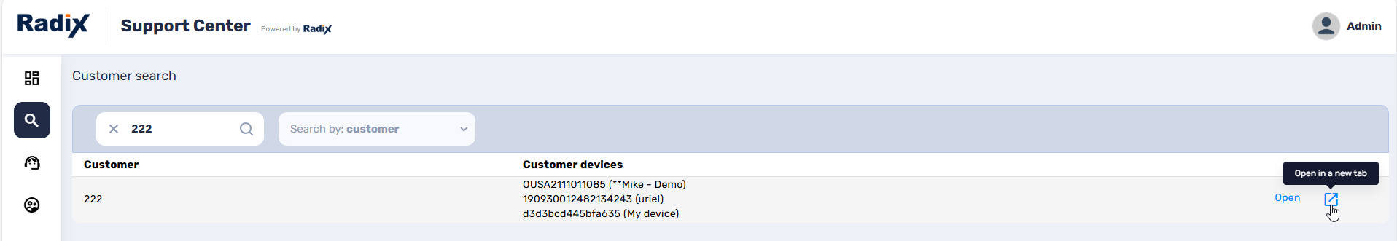
This opens the Household View console. It shows that Customer 222 has three Set Top Box devices in their fleet, and that one of the set-top boxes presently has an active Wi-Fi connection.
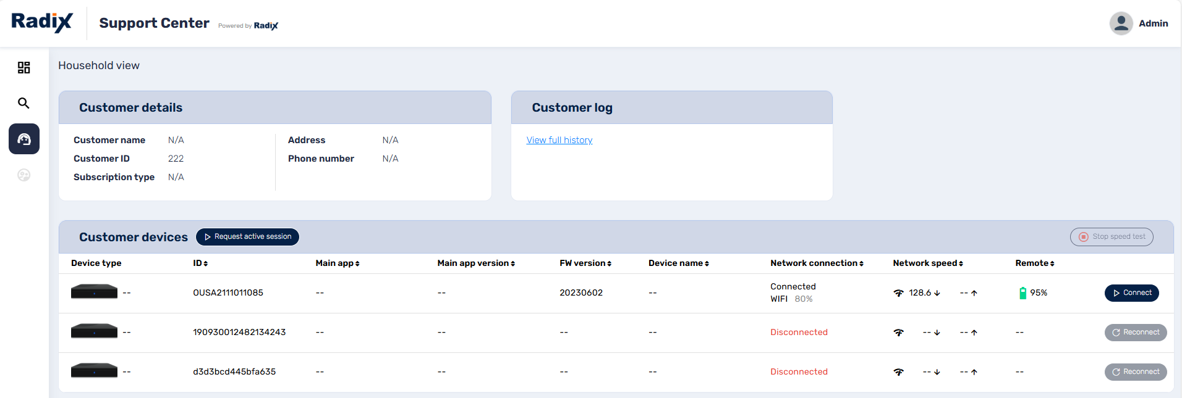
- We will click on Request Active Session, to initiate a new session with the devices. We receive a notification in the lower right corner that the session request was sent to the remote user.
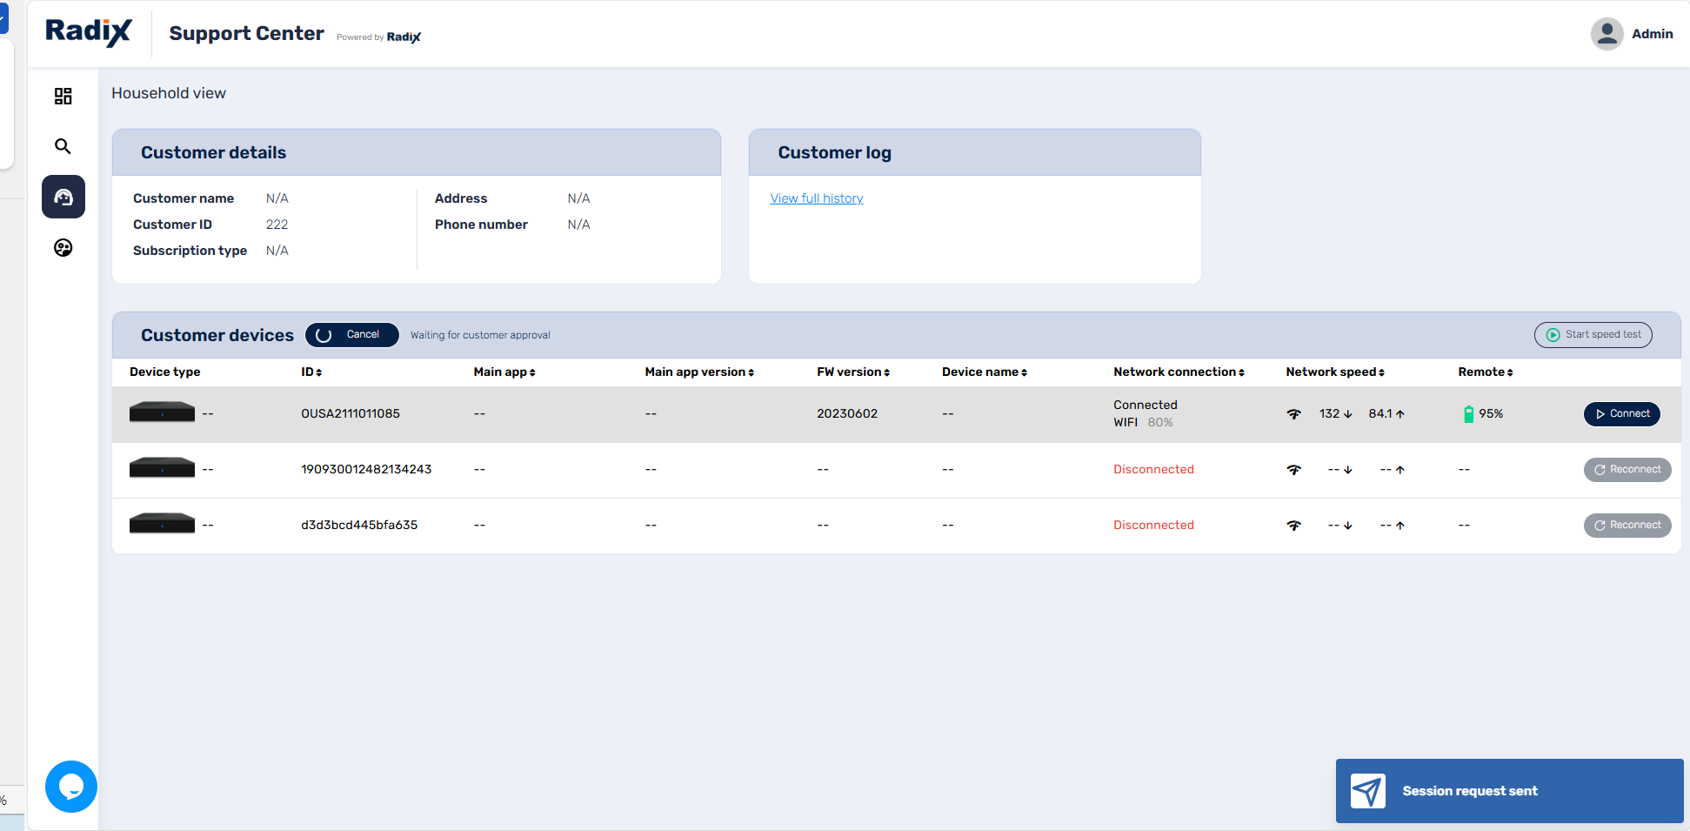
- We will click on Start speed test. It will initiate a test of upload and download speeds on all devices in the list.
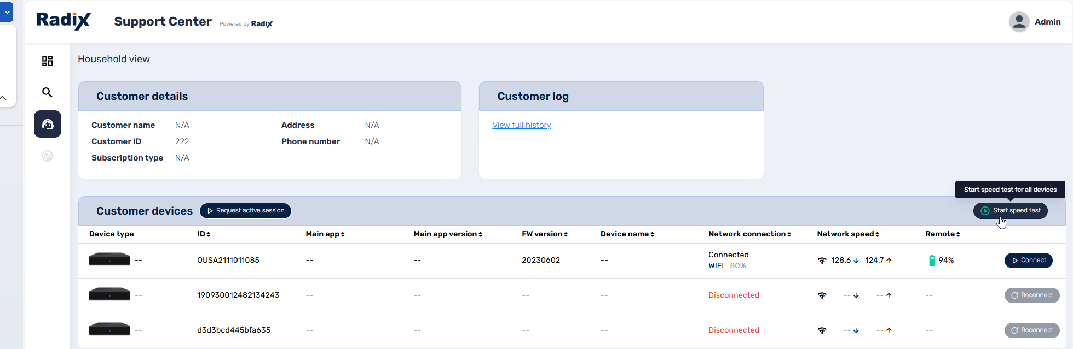
- We will now click Connect on the row of the connected device, to open the Selected Devices screen.
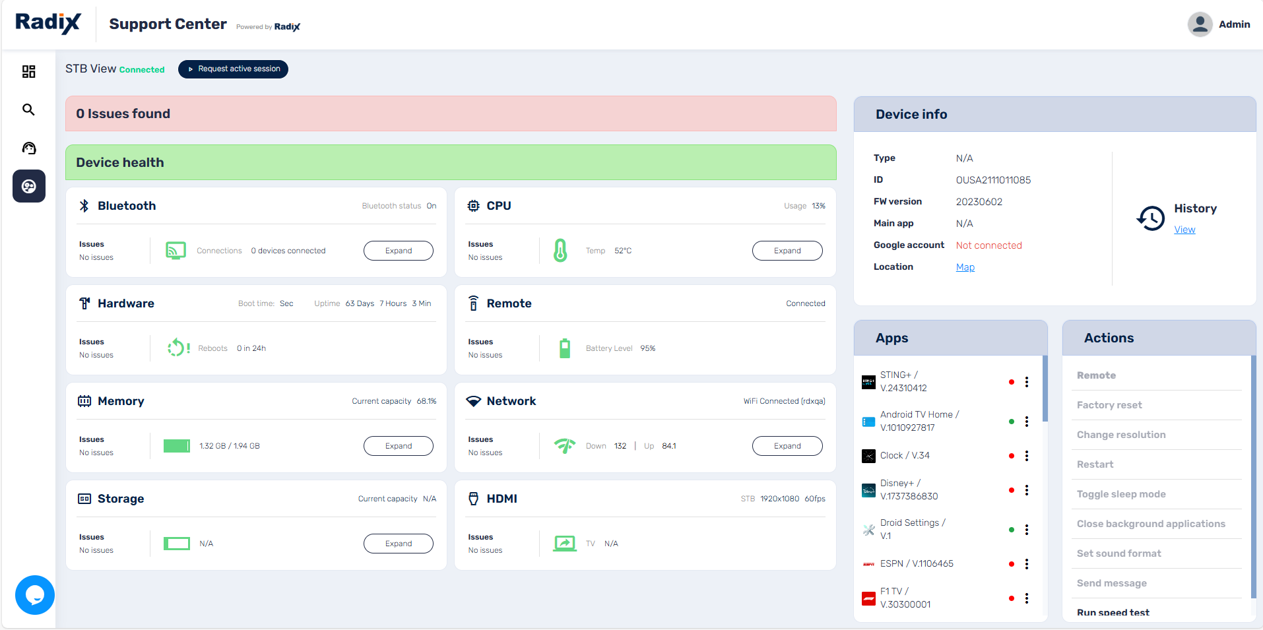
- We can click on the three-dot menu of one of the apps in the list. Let us select ESPN, and click on Start app.
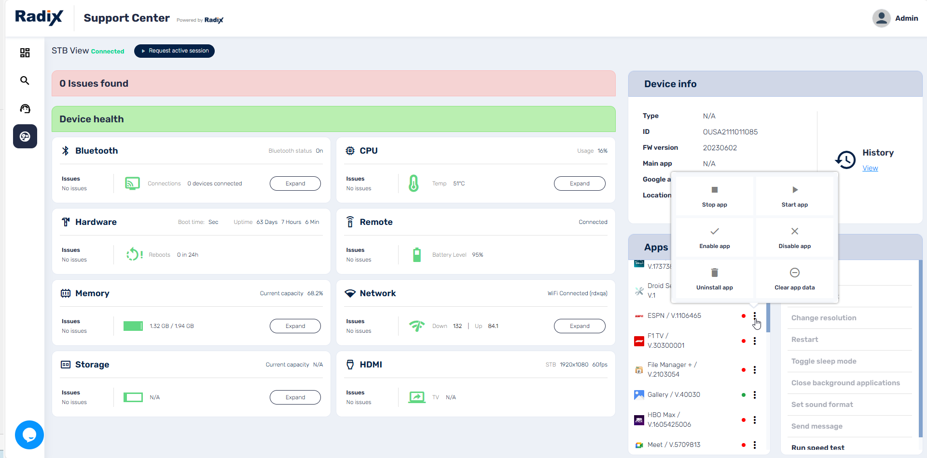
We receive notification that the command was sent to the remote device:
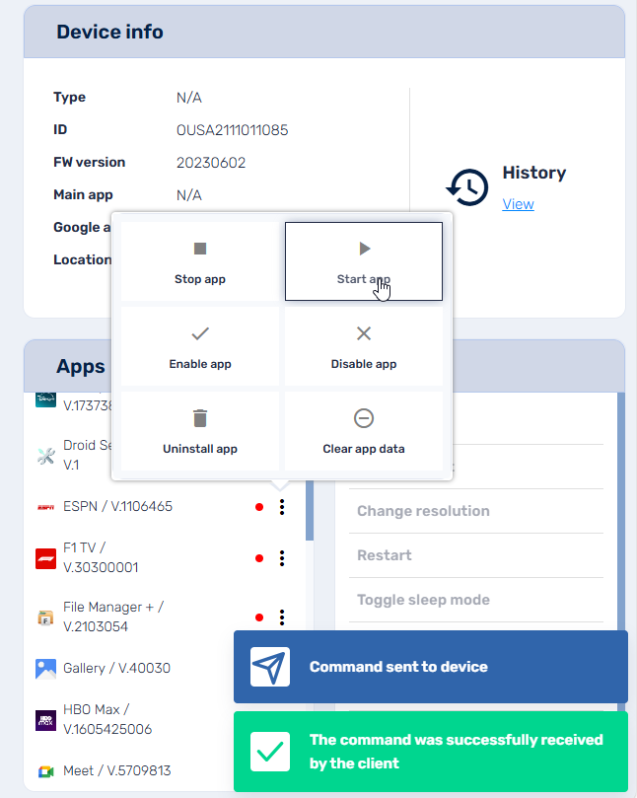
Let’s go back to the Support Center Dashboard. Our most recent session will be displayed in the Current Sessions window:
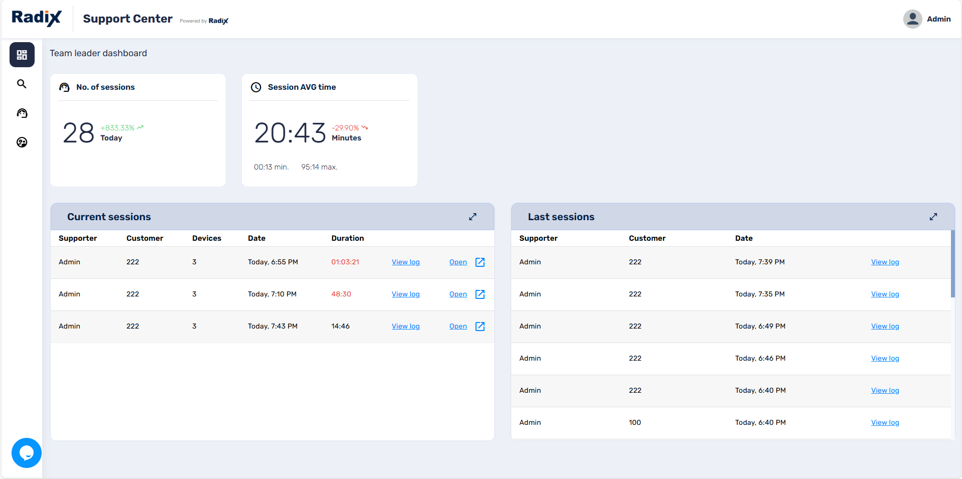
As the most recent session, it appears in black, while the previous sessions appear in red.
- If we click on View log, we can view the history of the session. We see the history of the request that we sent, the check of the download and upload speed, and how we started the ESPN app.
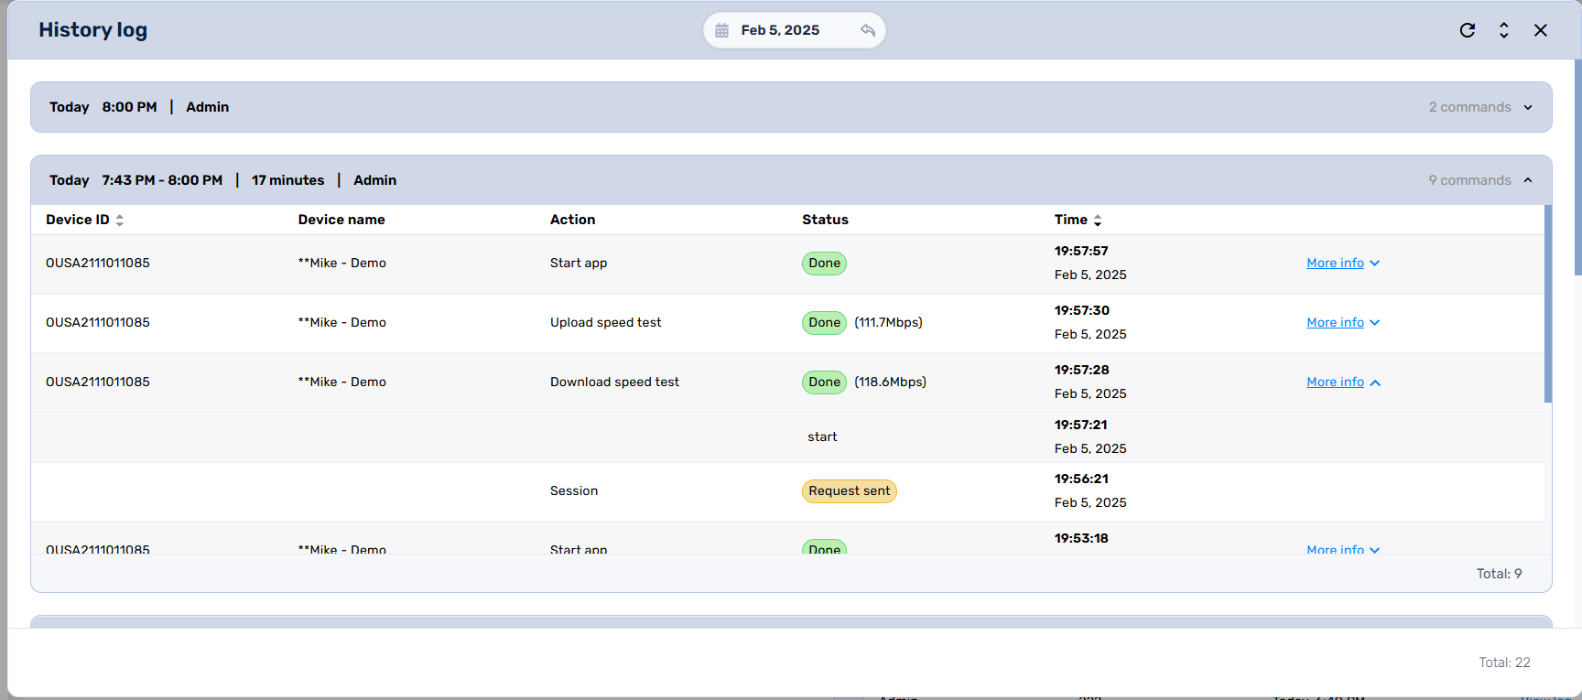

Further Resources
We have surveyed the main functions of the Radix Support Center interface, explaining the information displayed on each of the consoles.
Throughout the Radix Support Center interface, you have the option of completing a Customer Request Form by clicking on the dialog bubble in the lower left of the screen. Enter your name, email, and a brief statement of your request, and we will provide a response via email.
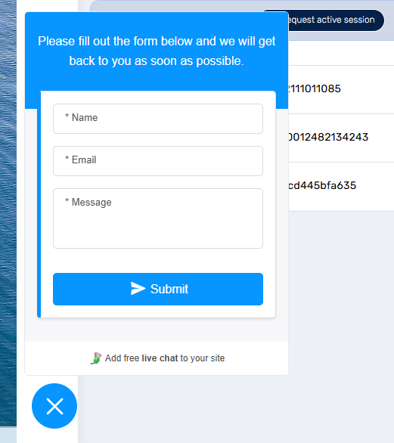
Figure ‎7-1: Customer Request Form
Besides the option to fill out a Customer Request Form, you can also register here for the Radix weekly webinar. The webinar is held every Monday and Wednesday at 3:00 AM EST/10:00 AM CET, and 10:00 AM EST/4:00 PM CET.
The Radix website also has an option to request a demo of the Radix MDM interface.

